**Datta Charitam**

Datta Charitam is a musical treatise by His Holiness Sri Ganapathy Sachchidananda Swamiji. The script and lyrics explain various aspects of Dattatreya Story, Philosophy and Teachings. The Mantra Aksharas (syllables), words and sentences of script are endowed with philosophical and devotional richness, resulting in great merit (Punyam) to the singers and listener alike.

This wonderful vision about Dattatreya is set to classical tunes in Carnatic style, by Vidwan Malladi SuriBabu and rendered by his illustrious sons and Datta Peetha Aasthaana Vidwans Sri Malladi Sriram Prasad and Sri Malladi Ravi Kumar.

By the virtue of singing and listening to these compositions, which take about an hour, the singer and listener have the benefit of completing the Datta Darshana (Charitra) Parayanam. May the Almighty bless all of you with the vision of Sadguru Dattatreya.

Theme of the Krutis

# Ganapathi- Saurashtram--- MisraChaapuhttp://www.vinayagar.myewebsite.com/img/picture/9/Bala-Ganapati.JPG

This Keertana invokes Ganapathi and prays for the successful completion of this work. Since this is a musical effort, Sri Swamiji addresses Ganapathi as ‘ Naada Kalaa Prapoorana’ and ‘ NaadaSanga’, which means one who fulfils the art of music and gets absorbed in it. Sri Swamiji addresses Him as ‘Mulaadhaara’, which is the base of the Kundalini in Shaakteya worship. Sri Swamiji’sMudra, Sachchidaananda, appears in this song as in the others.

# SreeDattam- Shankarabharanam- Rupakam

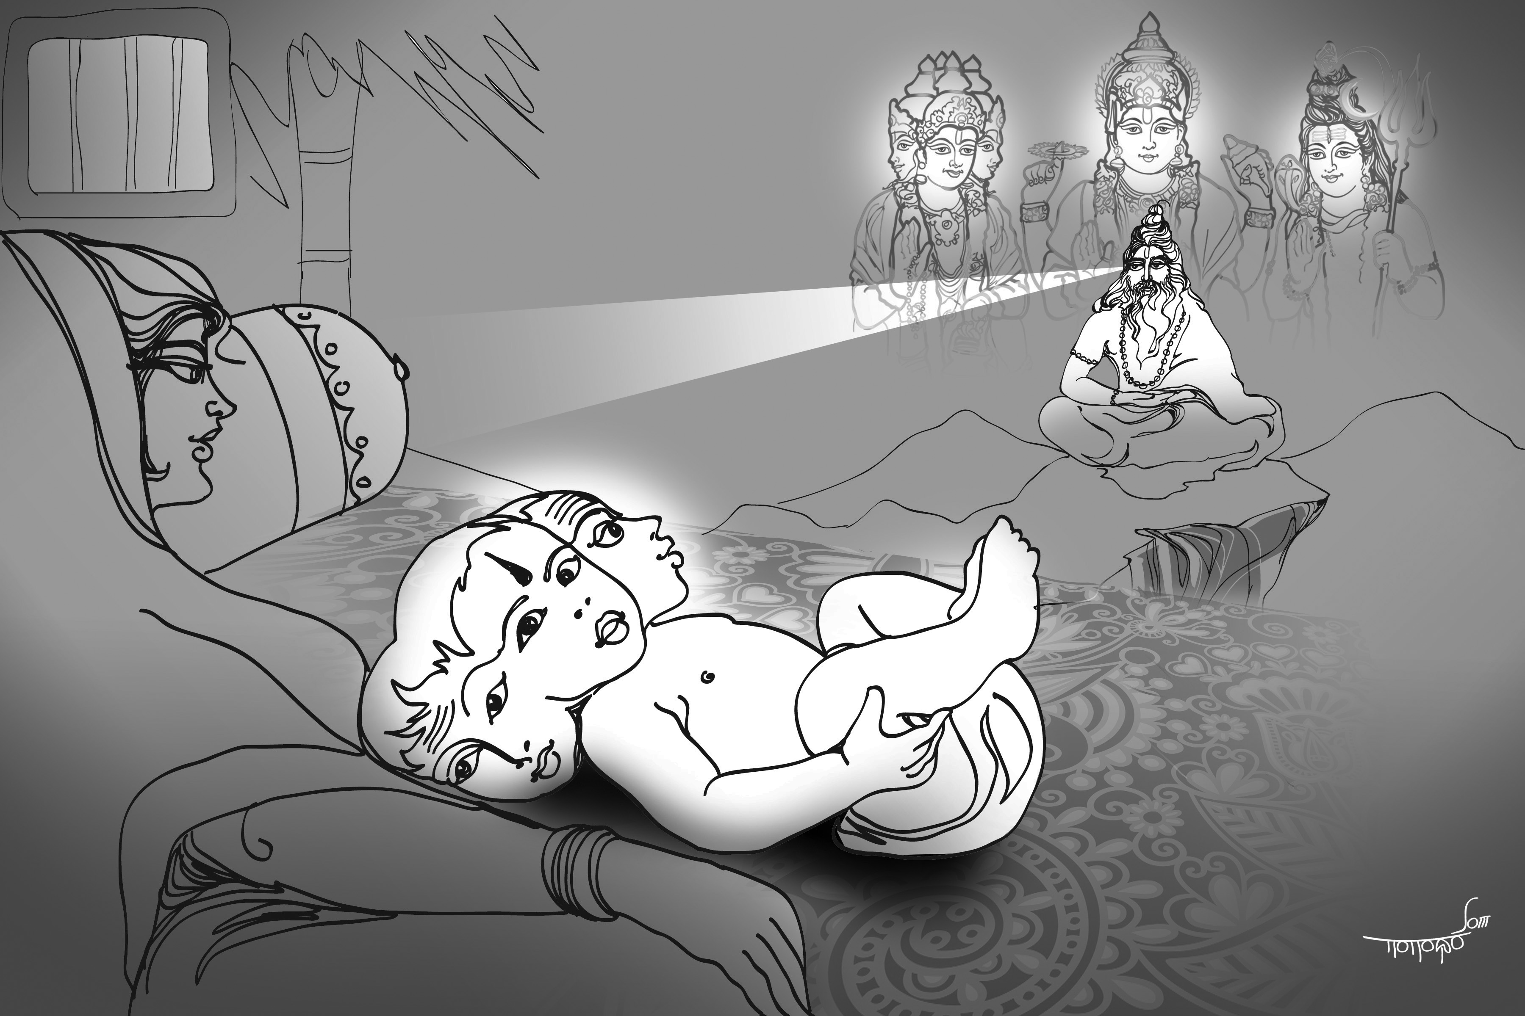

This Keertana speaks of the presence of Atri and Anasuuya and the incarnation of Lord Dattatreya on Margaseersha Poornima (full moon day). Sri Swamiji alludes to the significant character of this Avataara as a manifestation of Brahma, Siva and Vishnu. Sri Swamiji deftly uses his Mudra to express the special attributes of Dattatreya.

# Aadyam Gurum- Vanaspati- Aadi

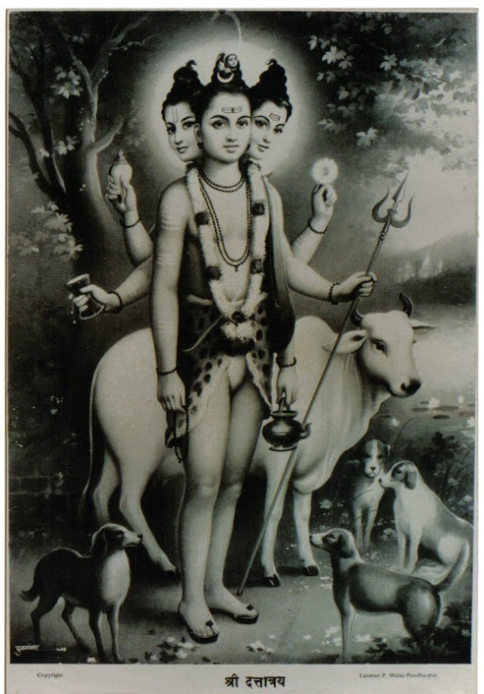

This Kriti glorifies the concept of the Guru and says that He, Guru Datta, alone can liberate us. He alone knows about the origin and the dissolution of the Cosmos.

# He Baala Guru- Saama – KhandaChaapu

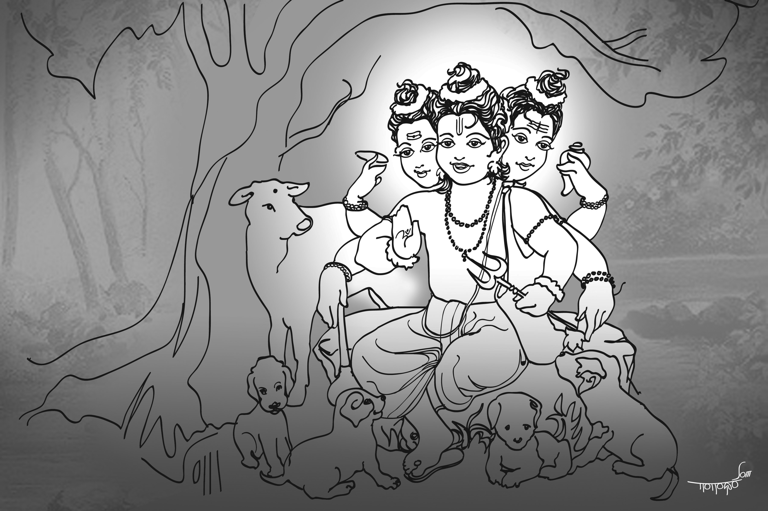

In this Kriti ,Sri Swamiji describes the childhood pranks of the great son of Atri and Anasuuya, Baala Guru Datta. It is lullaby-like in its lilt. Sri Swamiji prays to Baala Guru to put to sleep the six internal enemies (Ari shadvarga) just as he Himself sleeps in the cradle. The use of the colloquial ‘ JoJo’ in a Sanskrit composition is yet another feature of this song.

# Moha Viduuram–Mohanam- Aadi

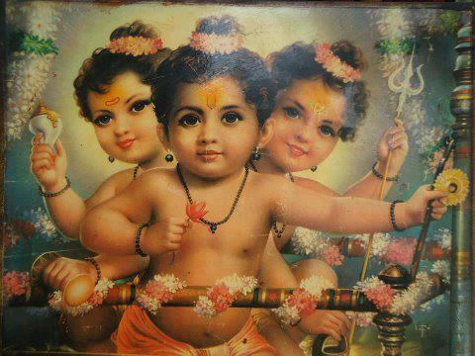

This Kriti describes the Leelas of Baala Guru Datta , who attracts the Rishis with His bewitching smile. Note the use of onomatopoeia (sound echoing sense) in this composition.

# EekshaaMahe – Sarasaangi- MisraChaapu

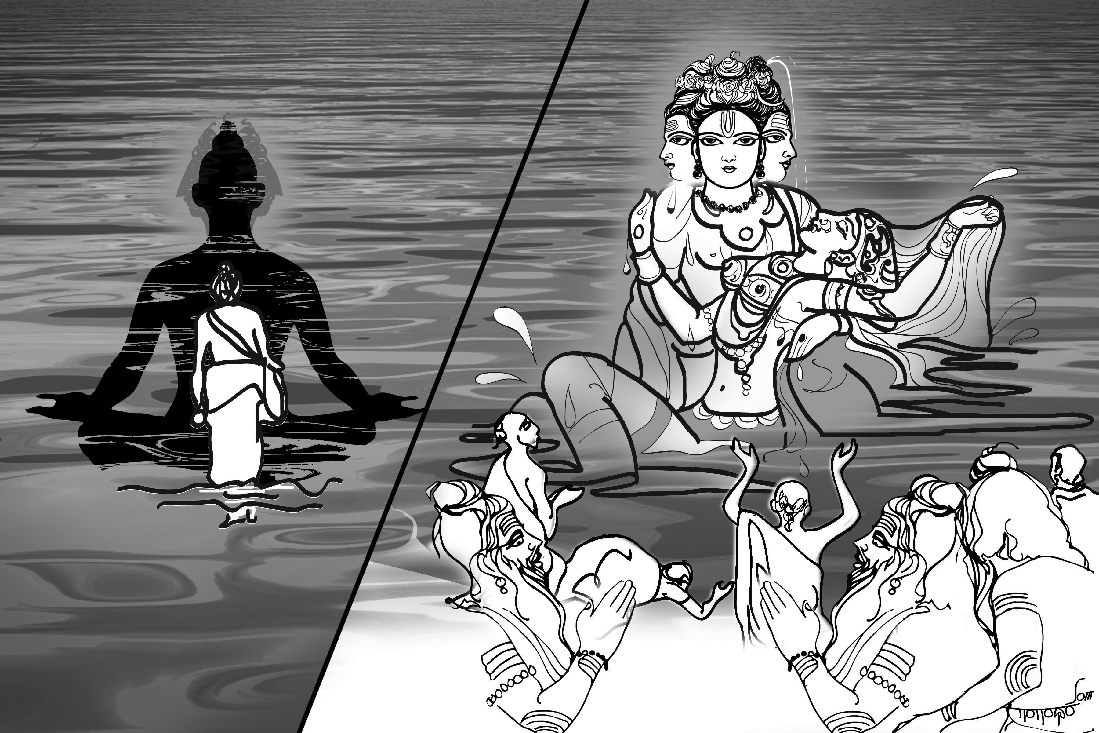

In this Kriti the youthful Datta’s wondrous exploits of testing the faith of His disciples, by disappearing into the waters and resurfacing a hundred years later with a beautiful Apsara are decribed. The Raaga’s name is also cleverly woven into the texture of the song.

# ParamaGurum- Kanakaangi- Rupakam

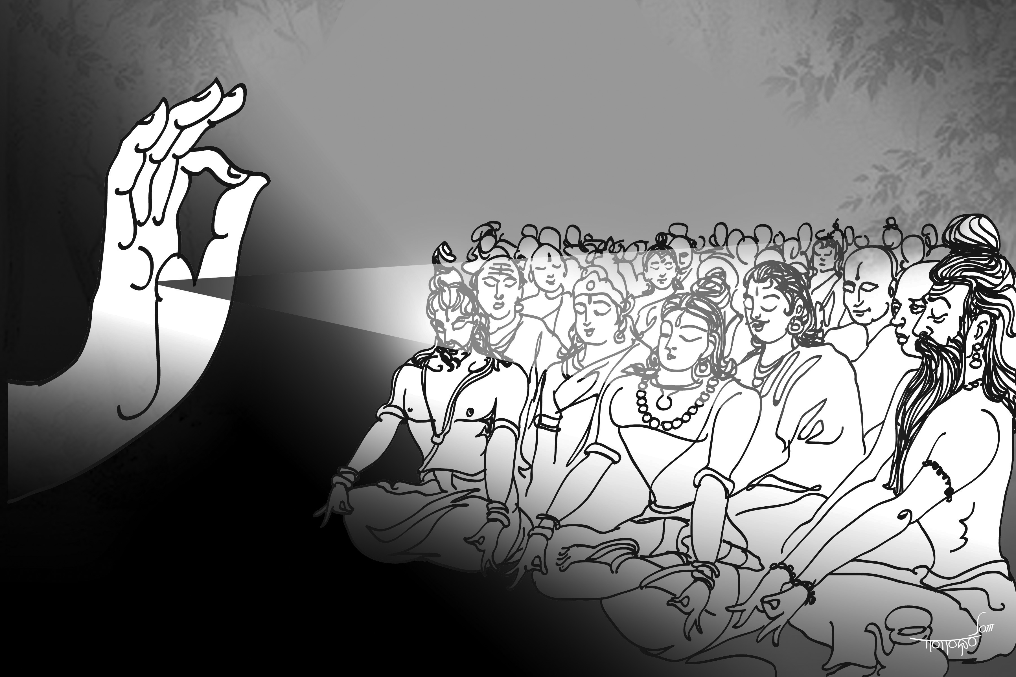

This Keertana declares that without the Grace of the Guru one cannot get salvation.Even Prahlaada was liberated due to the Benediction of Datta Guru.The Guru is an ocean of compassion.

# JagatGurutvam- Nata Bhairavi- Aadi

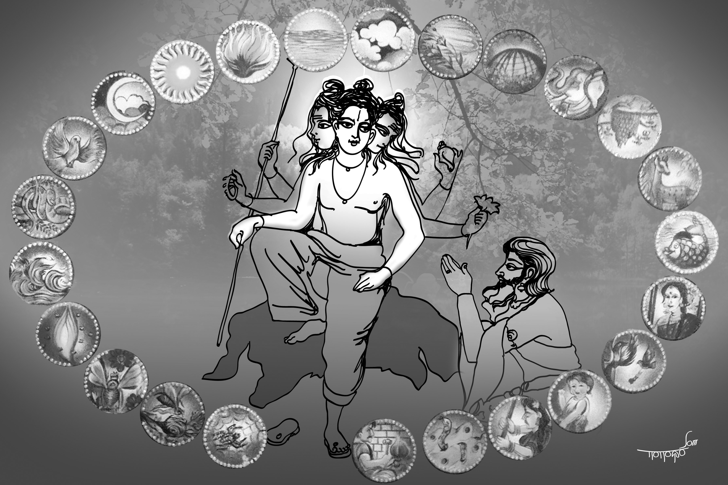

This song describes the blessings given to Yaduraaja by DattatreyaSwaami, and how Dattatreya declares Himself an Avadhuuta and indicates that every devotee has twenty- four Gurus ( beginning with the elements and ending with the honey-bee and the spider) spread out in the Universe.

# AatreyaDevam- Harikambhoji---Aadi

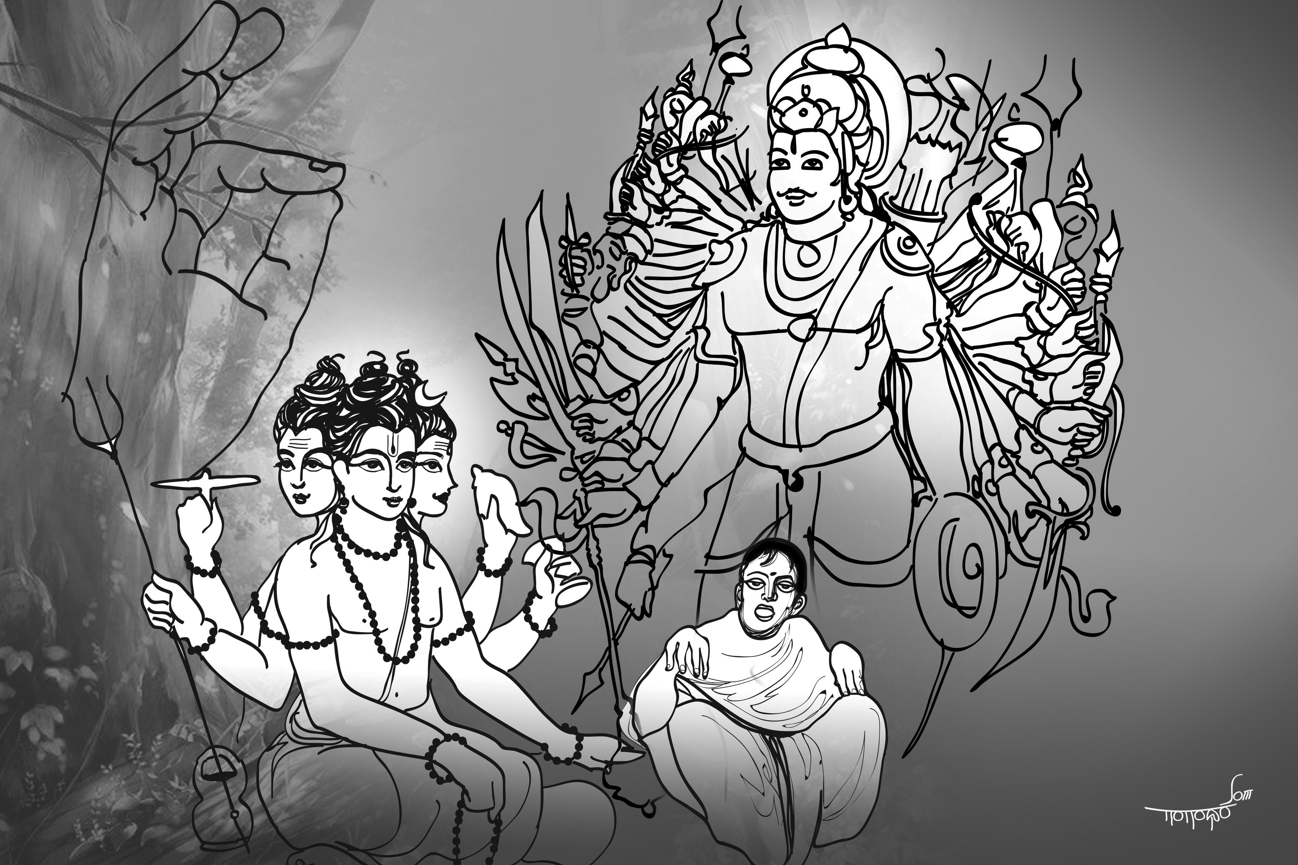

This Song describes the life of KaartaveeryaArjuna, the great devotee of DattaSwaami, and how he gained liberation.

# KimVarnayeyam- Dhanyaasi- KhandaChaapu

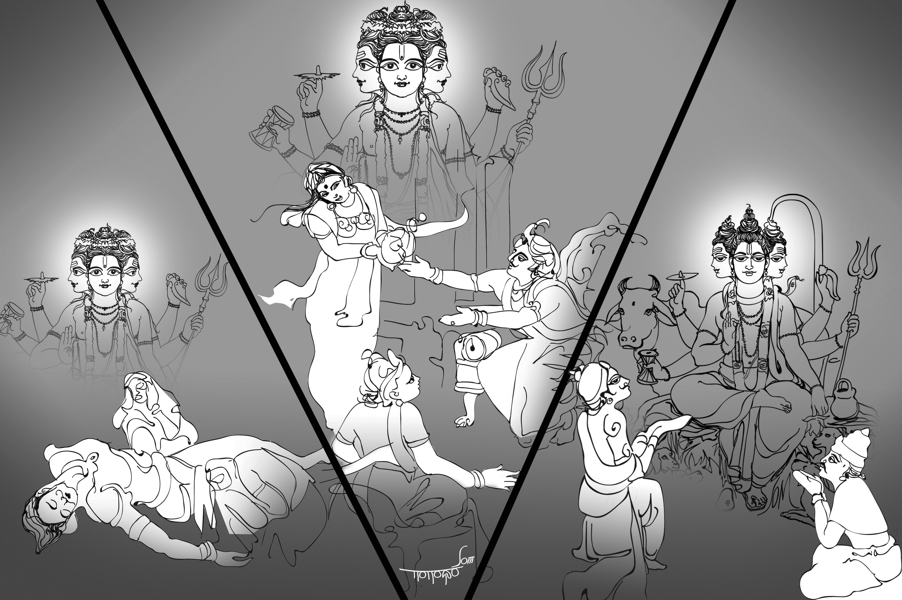

In this Keertana the compassion of Datta Guru is highlighted and described elaborately, a compassion which liberated Taamasic sinners, a Raajasic devotee like KaartaveeryaArjuna, and Saatvic devotees like Dharmakeerti and Bhadraseela.

# ParasuraaamaPriyam- Raamapriya-------MisraChaapu

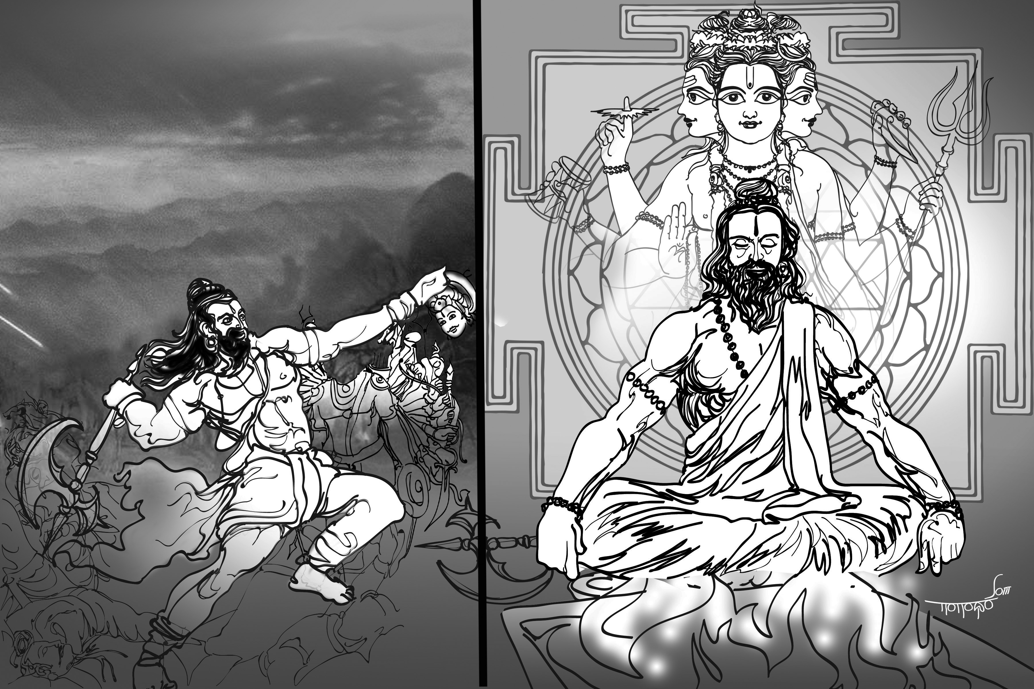

This Kriti alludes to the Shaakteya tradition , the benediction received by Parasuraama from Datta Guru, and the liberation given to PingalaNaaga. The importance and the mystic significance of Sandhya is touched upon.

# Parameshthee- Surati- Aadi

This is a MangalaKriti which praises the Lord Datta Guru and His other manifestations like SreePaadaVallabha and NarasimhaSaraswathi.

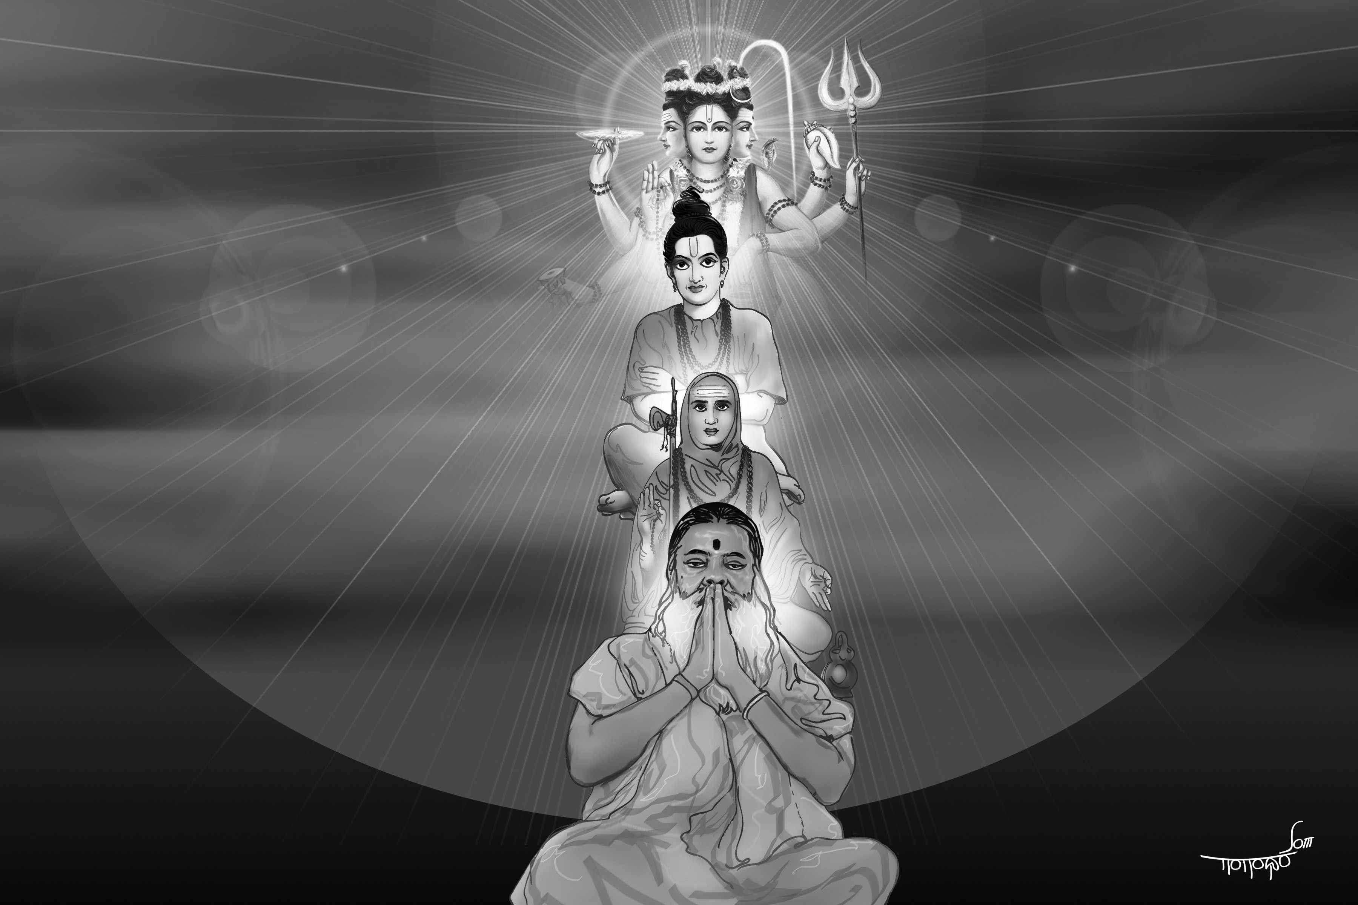

**Art - K Soma Shekhar (Gangadhar), Bengaluru**

**CD Sponsored by - Pammi Venkata Ramanayya, Bheemavaram**

**Coordinated by - Dr. Vamshi Krishna Ghanapathi, Mysore**